Ken-Wo Golf Club’s Coors Light 2-Man Scramble
Presented by

Many thanks to our major sponsor Molson Coors Canada and our presenting sponsor TaylorMade Golf. A BIG thank you goes to the many volunteers who helped make this event a success and to all committee and staff members who worked long hours to have the event run smoothly. Thank you for playing in this year’s tournament and we look forward to hosting you at Ken-Wo Golf Club in 2021.

Overall Champions:
Richard Cashen & Alex Butt from Brightwood
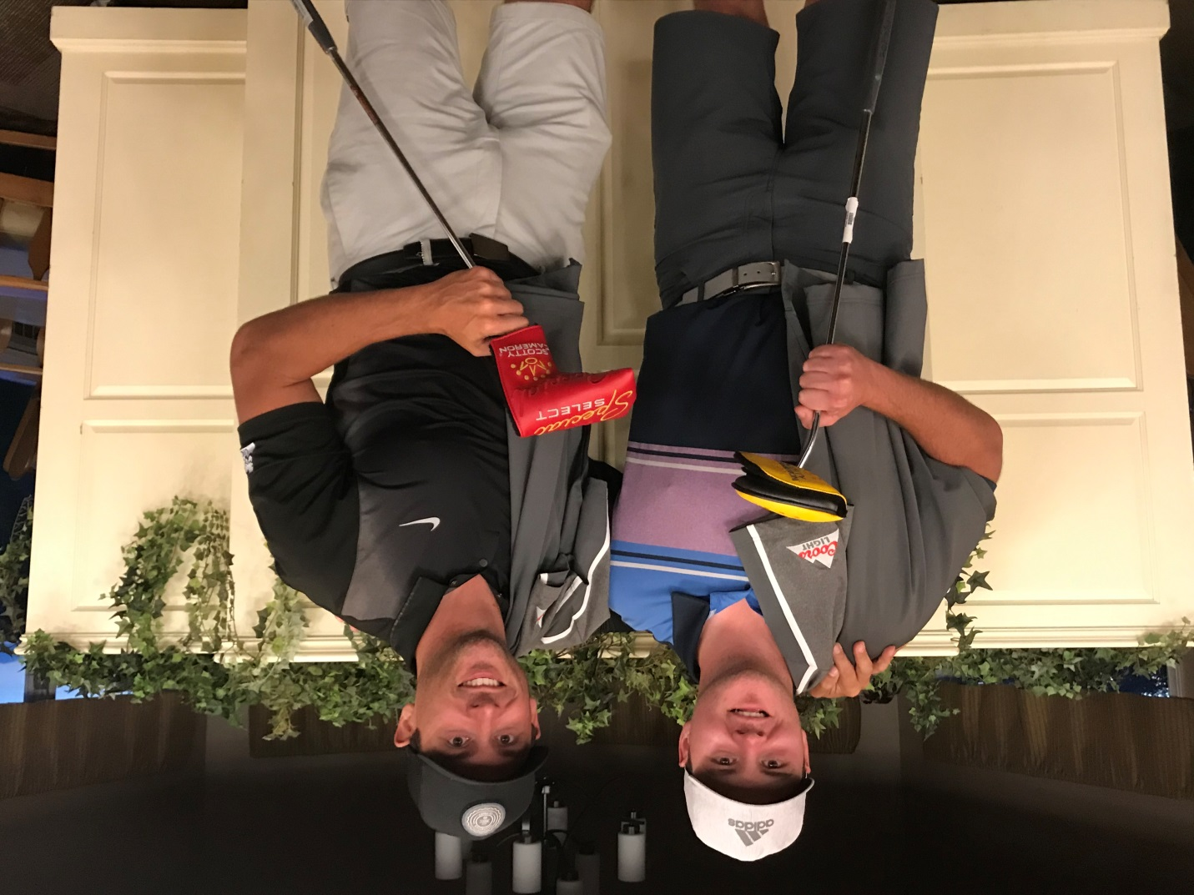

2020 Final Results
Division 1 & 2
Overall Champions
Richard Cashen (BRI) Alex Butt (BRI) Score: 123
Division #1
1st Gross Mark Pothier (KW) Jason Thibodeau(KW) Score: 124
1stNet Ryan Power (KW) Jeff Power (Lakes) Net Score: 121
2nd Gross Geoff Campbell (OAK) Steve Ward (KW) Score: 125
2nd Net Kyle Davison (KW) Ryan Trimper (KW) Net Score: 123
3rd Gross Nick Pearl (KW) Sean O’Flaherty (KW) Score: 128
3rd Net Mason Cook (BRI) Denis Wisener (BRI) Net Score: 124
Division #2
1st Gross John Bulley(KW) Evan Bayers (NSPP) Score: 129
1stNet Chris Henshaw (KW) Jon Chisholm (KW) Net Score: 120
2nd Gross Alex Simpson (RV) John Simpson (RV) Score: 131
2nd Net Matt Chaput (KW) Remi Poirier (KW) Net Score: 121
3rd Gross Justin Matthews (AMH) Joel Stronge (AMH) Score: 132
3rd Net Sam Wright (FV) Wyatt McGarvey (FV) Net Score: 123

Division 3 & 4
Overall Champions of Division 3 & 4
Mark Boudreau (KW) Paul Mason (NSPP) 66, 63 = 129

Division #3
1st Gross Mark Simpson (RV) Colin Best (RV) Score: 131
1stNet Kyle MacLean (AV) Dean MacLean (AV) Net Score: 113
2nd Gross Rod Spike (OAK) Peter MacDonald (OAK) Score: 132
2nd Net Scott Nause (GV) Paul Tordon (GV) Net Score: 115
3rd Gross Brett Spicer (GV) Tyler Lopez (NSPP) Score: 134
3rd Net Ewan Kelly Sr. (PH) David Williams (PH) Net Score: 115
Division #4
1st Gross Keith Snair (PAR) Andrew Snair (PAR) Score: 137
1stNet Matt Hoebrecker (NSPP) / Bruce Read (NSPP) Net Score: 109
2nd Gross Greg Probert (PH) Cory Preeper (PH) Score: 139
2nd Net Charles Probert Sr (PH) Charles Probert Jr (PH) Net Score: 111
3rd Gross Mason Nickerson (RH) Matt Goodwin (RH) Score: 140
3rd Net Ben Rodgers (BRI) Andrew Bonazza (BRI) Net Score: 113

RANGS
Day 1 – D1&2:
Richard Cashen & Alex Butt #3
Nick Pearl & Sean O’Flaherty #6
Mason Cook & Brad Wisener #17

Day 1 – D3 & 4:
Jerry Vantassel & Brian Comeau #2
Greg Probert & Corey Preeper #17
Day 2 – D1&2:
Alex Feltmate & Chris Josey #6
Day 2 – D3 & 4 :
Mark Boudreau & Paul Mason #10
Ben Rodgers & Andrew Bonazza #16

